Lab 4 Computer Networks – Network Topographies

Name: Tanvi Penumudy

Enroll No: E18CSE187

Network Topology refers to the layout of a network and how different nodes in a network are connected to each other and how they communicate. The following are the various network topographies and their design on Cisco Packet Tracer.

1.Bus Topography: Alternatively referred to as a line topology, a bus topology is a network setup where each computer and network device is connected to a single cable or backbone. Depending on the type of computer network card, a coaxial cable or an RJ-45 network cable is used to connect them together. It's the easiest network topology for connecting computers or peripherals in a linear fashion.

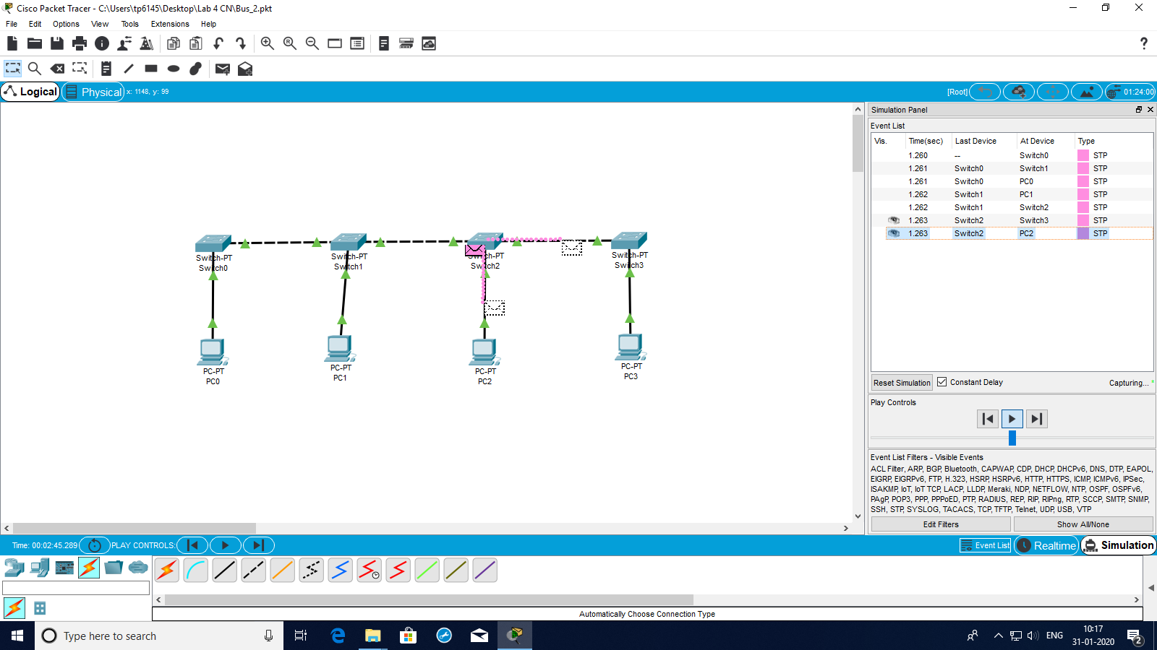

2.Star Topography: Alternatively referred to as a star network, star topology is one of the most common network setups. In this configuration, every node connects to a central network device, like a hub, switch, or computer. The central network device acts as a server and the peripheral devices act as clients. Depending on the type of network card used in each computer of the star topology, a coaxial cable or an RJ-45 network cable is used to connect computers together. The image shows how this network setup gets its name, as it is shaped like a star. Centralized management of the network, through the use of the central computer, hub, or switch. If one computer on the network fails, the rest of the network continues to function normally.

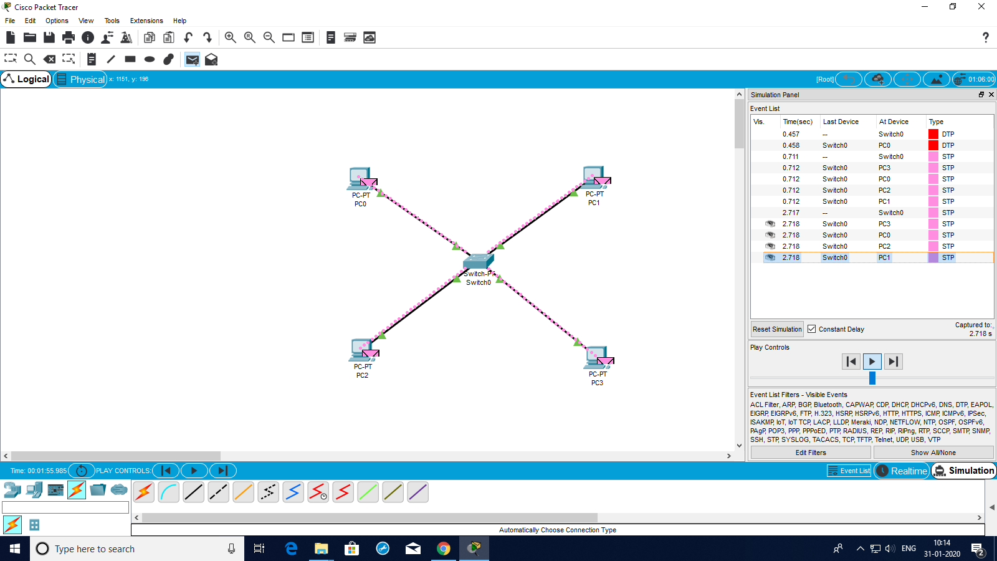

3.Ring Topography: A ring topology is a [network](https://www.computerhope.com/jargon/n/network.htm) configuration in which device connections create a circular [data](https://www.computerhope.com/jargon/d/data.htm) path. Each networked device is connected to two others, like points on a circle. Together, devices in a ring topology are referred to as a ring network. In a ring network, [packets](https://www.computerhope.com/jargon/p/packet.htm) of data travel from one device to the next until they reach their destination. Most ring topologies allow packets to travel only in one direction, called a unidirectional ring network. Others permit data to move in either direction, called bidirectional. The major disadvantage of a ring topology is that if any individual connection in the ring is broken, the entire network is affected.

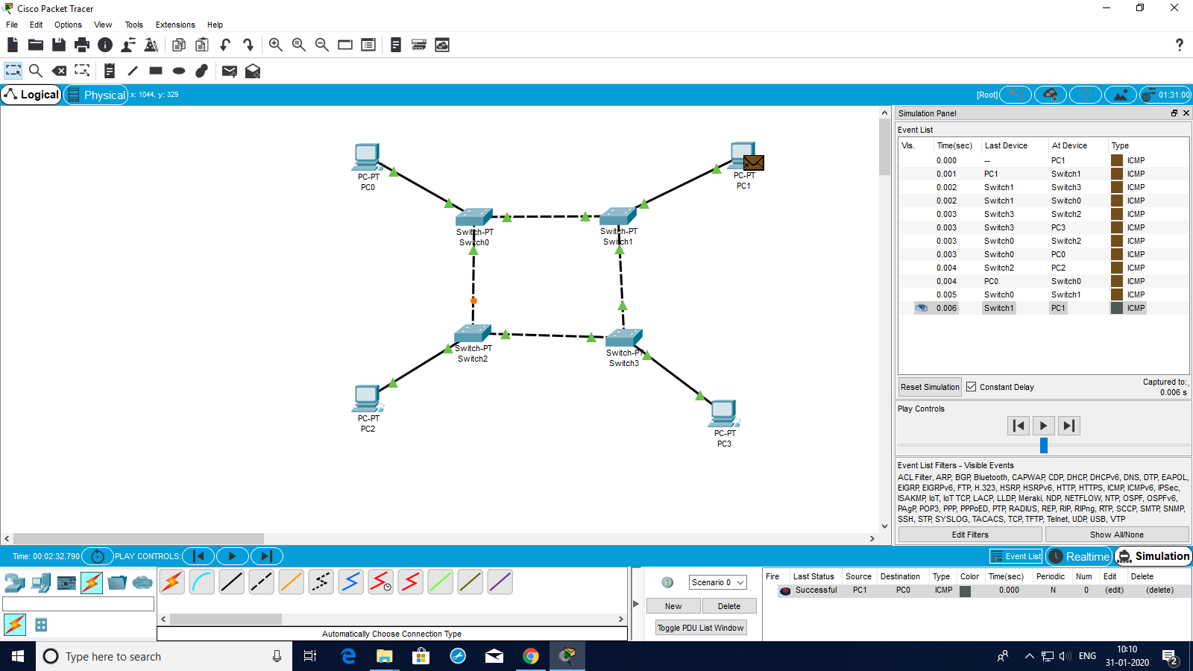

4.Mesh Topography: A network setup where each computer and network device is interconnected with one another, allowing for most transmissions to be distributed even if one of the connections go down. It is a topology commonly used for [wireless networks](https://www.computerhope.com/jargon/w/wifi.htm). The below network designed on Cisco Packet Tracer is a visual example of a simple computer setup on a network using a mesh topology. A mesh topology can be a full mesh topology or a partially-connected mesh topology.

Continued on Next Page..

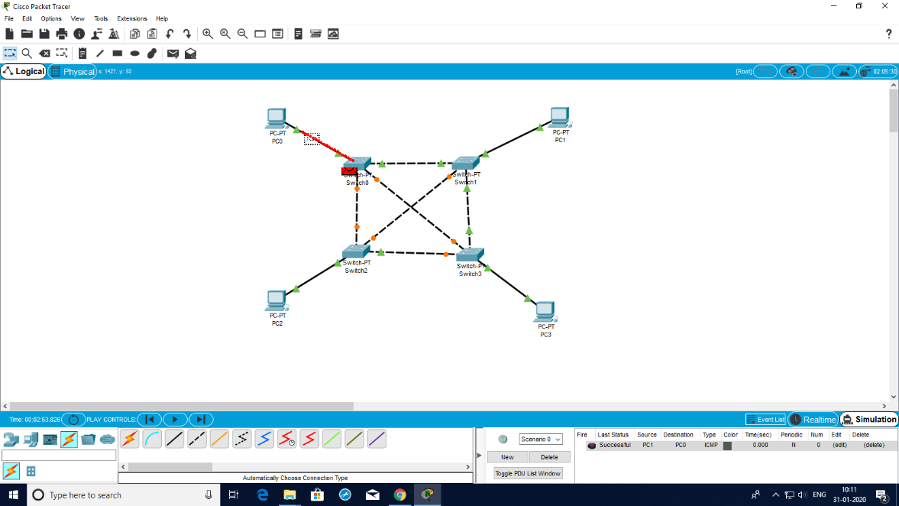

5.Hybrid Topography: Hybrid topology is an interconnection of two or more basic network topologies, each of which contains its own nodes. The resulting interconnection allows the nodes in a given basic topology to communicate with other nodes in the same basic topology as well as those in other basic topologies within the hybrid topology. It could be the combination of the one or more of the above four topographies mentioned. The below is an example of the hybrid topography designed by the combination of all four of them on Cisco Packet Tracer. 